Homework-1 StarterBook Report

1. What are three conclusions we can make about Kickstarter campaigns given the provided data?

**Conclusion One**: In 2009-2017, Theater Category has the most submissions and the sub category “Plays” has the greatest number of projects that pledged successfully among the whole.

**Conclusion Two:** In 2009-2017, within the “Technology” category, hardware has a perfect score, 100% of the successful rate!! There are also other sub categories have such a good performance, another impressive one is rock music” – all 260 submissions are successfully pledged.

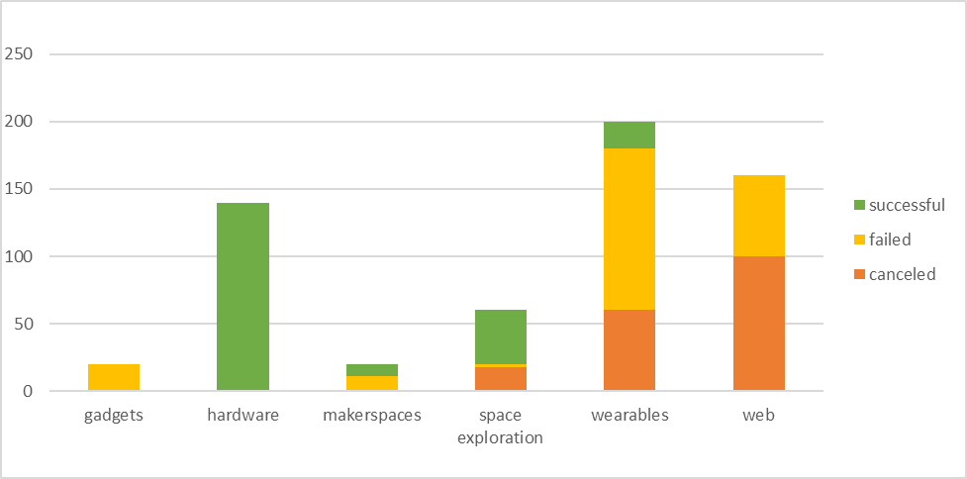

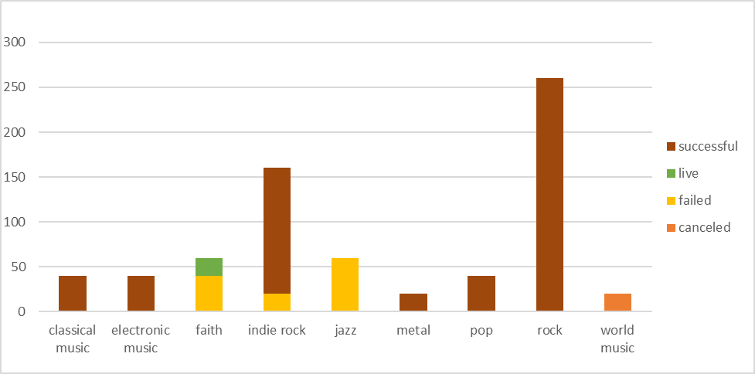

**Conclusion Three:** In 2009 to 2017, successful pledged projects and live projects in generally have a smaller goal amount compared with canceled and failed projects.

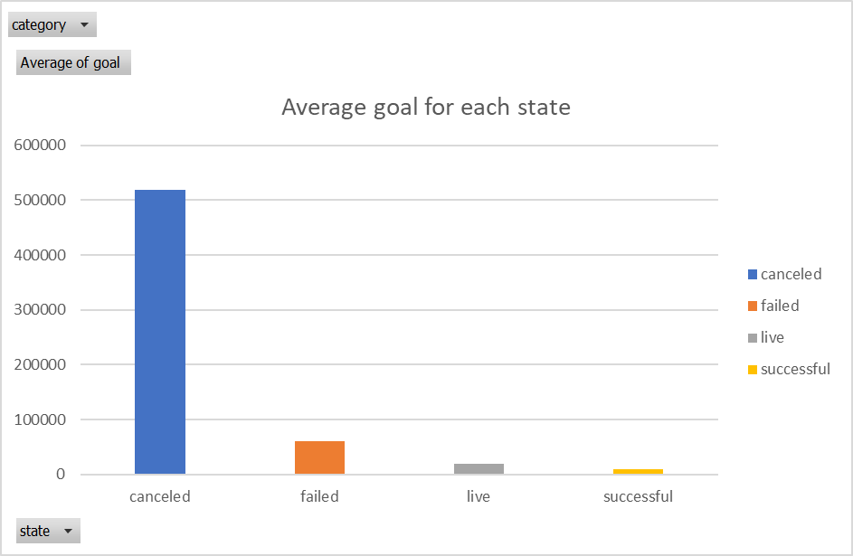

1. What are some of the limitations of this dataset?

I will discuss the limitations of this dataset based on if the audience want to use this dataset to determine what kind of projects will have a higher chance to pledged successfully and then take actions according to it:

* The number of projects selected from each sub category are not same, so it has statistical bias to decide which project to start can have a higher successful rate.
* The backers from the Kickstarter can from different background that can be different from rational investors. For example, the projects that have higher pledged may have other advertise activities at the same time, so their fans are willing to send the donate without rational evaluate.
* The project with a small goal tends to have a higher successful rate, because the goal is easy to achieve, so it’s hard to determine which category is a good one to start based on the successful rate.
* Pledge successful doesn’t mean the project will be successful eventually, so if the audience is looking for a project that is sustainable-successful then this dataset will have bias, the data of the life period of the successful pledged project will be needed in this case.

1. What are some other possible tables/graphs that we could create?

I have created “Other Visualizations” tab for this one. The top chart tells the trend of number of successful projects over the years, the bottom chart shows the average goal asked by projects from each state.